SPEAKING SKILLS

Part.I
Introduction – What is Speaking ?
Speaking is also productive skills, like writing. It involves using speech to express meaning to other people.
The important categories for Speaking are :
❖ Grammar and Vocabulary [ use tenses].
❖ Functions [answer questions, ask for clarification, take part in discussions, greet people, ask for and give
Information, responds appropriately, persuade, tell stories.]
❖ Features of connected speech [pronounce words].
❖ Appropriacy [respond appropriately].
❖ Body language [smile, using facial expressions].
❖ Interaction [ correct themselves, change the content or style of their speech according to how their listener responds, start speaking when someone else stops, take part in conversations.]

We speak with fluency and accuracy. Fluency is speaking at a normal speed, without hesitation, repetition or self-correction, and with smooth use of connected speech. Accuracy in speaking is the use of correct forms of grammar, vocabulary and pronunciation.

Speaking requires:
- Sharp focus
- Logical thinking
- Clear phrasing
- Crisp delivery.

Part.I. Role plays
Making Requests & Respond to requests. Speaking sample Audio.1
Could you give me your pen?
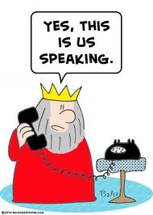
Could you possibly give me your pen?
Please Can you give me your pen?
Will you please give me your pen?
Would you mind giving me your pen please?
Do you mind giving me your pen please?
Do you mind if you giving me your pen please?..
Would it be alright if you give me your pen?
Would you be so kind as to giving me your pen please ?
I request you to give me your pen?
It’s my request to you too …….
Role Play: - 1. You have been asked to submit a project proposal by tomorrow morning. You are not completely prepared for it. You need another day to finish it. You want to ask your HOD for the extra time.
Role Play:-2. You are applying for a driving license. You are talking to the RTO. You have been asked to submit proof of date of birth. Find out what certificate you would like to submit.

PART.II. Speaking sample Audio.2
Accepting Help or go forward to help others:- 1. Can or May I help you ?
Would you like me to do that for you?
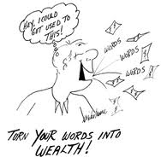
Let me get it for you ?
Would you like me to get it for you?
Any point in my getting it for you?
What can I do for you?
Do you need any help ?
Is there anything I can do to help you ?
How about me getting it for you ?
If you want, I could get it for you?
Can I help you with that?
Would you like some help
Role Play .4. A is hurrying to leave for Chennai to attend an interview and is talking to B.
B < Offer to lend him/her some money
Offer to arrange for accommodation in Chennai with a friend. Offer to drop him/her at the station on your bike

A > 1.Say you want to go to Chennai this evening to attend an interview. You are in need of some money. Than B for the help. Decline the offer. Say that you will be staying with your relatives. Accept the help

